**Experiment: 05**

**AIM : Designing the BOOKS R US website and adding JSP.**

**Screenshots:**

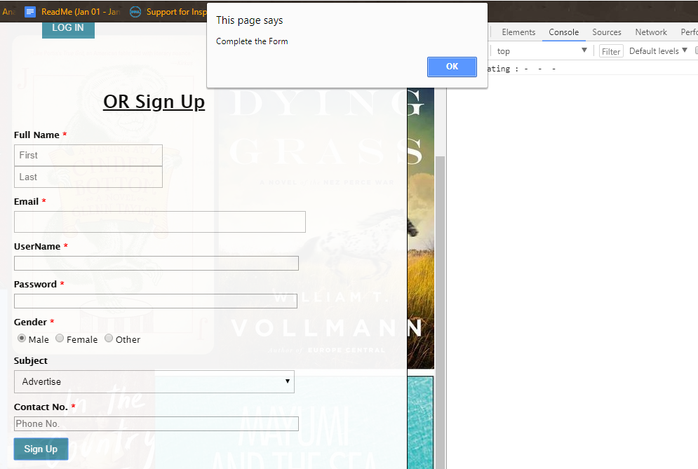

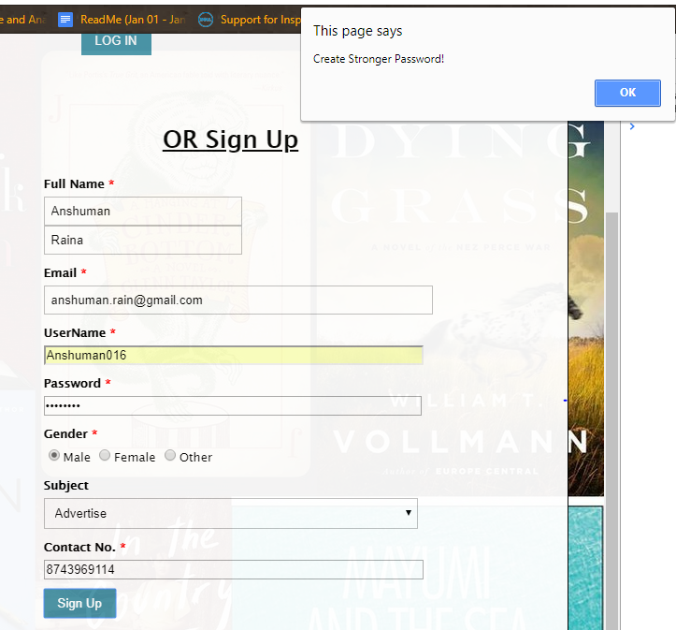

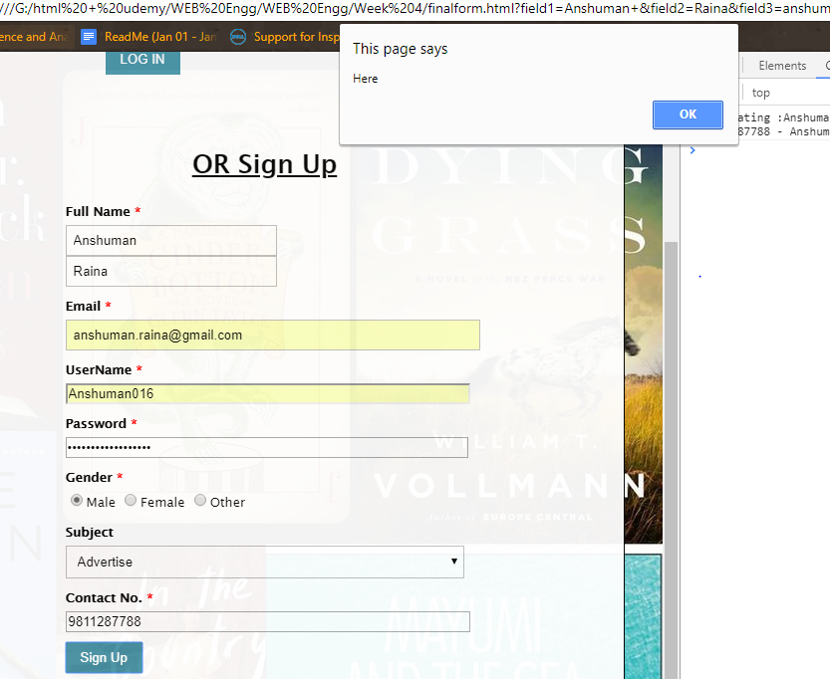

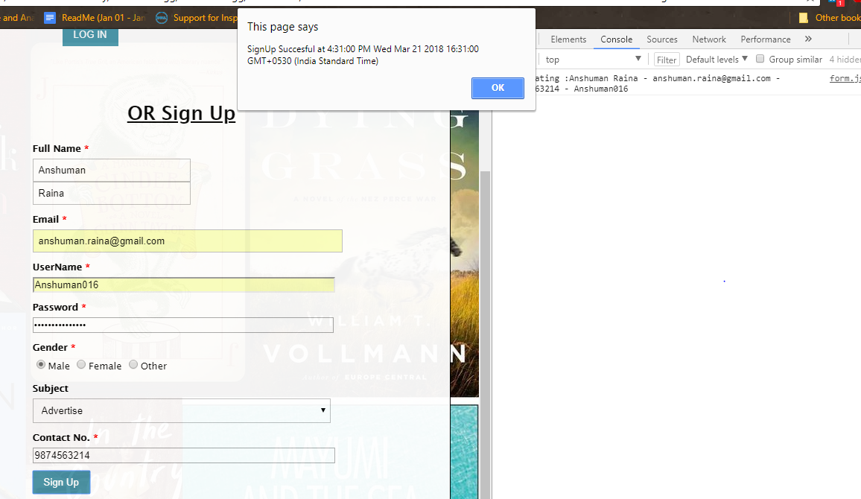

**Experiment: 06**

**AIM : Designing the BOOKS R US website and connecting it with a DataBase.**

**Screenshots:**